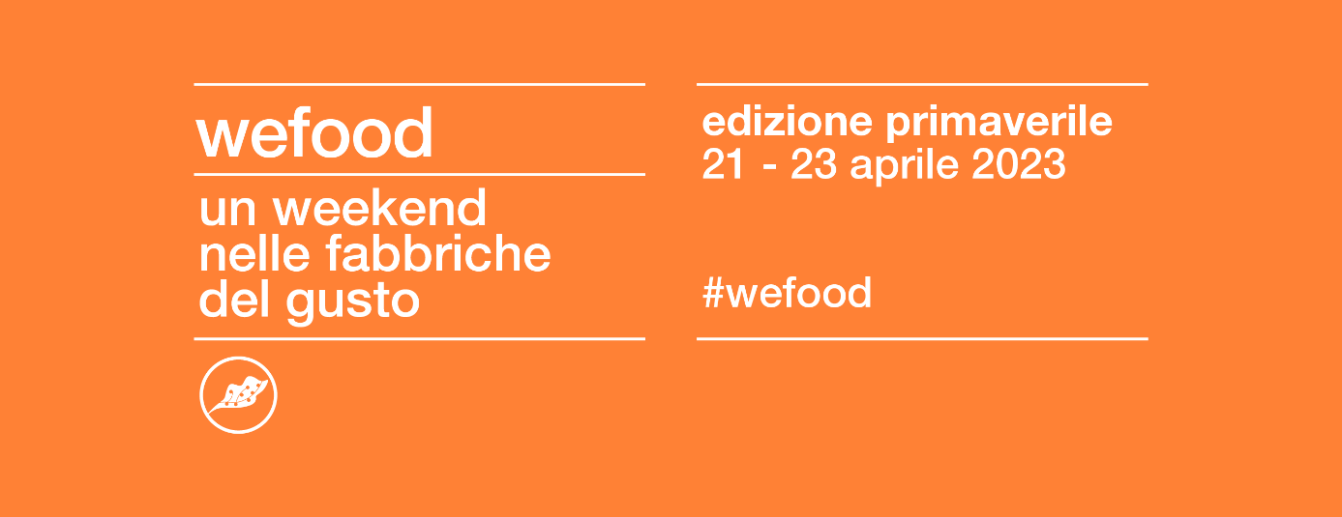
International Fellowship
___

WEFOOD: DISCOVERING THE TASTE FACTORIES
Spring Edition: 21 - 23 April 2023

VISITING THE «TASTE FACTORIES»: AN ITINERARY - IN ENGLISH LANGUAGE - TO DISCOVER FOOD&WINE EXCELLENCE IN EMILIA ROMAGNA, LOMBARDY, VENETO, FRIULI VENEZIA GIULIA AND TRENTINO
___

First deadline for applications: Sunday 26 February 2023

Applications are now open for the Spring edition of the WeFood International Fellowship, a 3-day intensive program to discover food&wine excellence that will take place from Friday 21 to Sunday 23 April 2023.
The WeFood International Academy is specifically designed for English-speaking BA, MA and PhD students and offers the possibility to students to meet, exchange knowledge and train, through active participation in the event that allows to:
- discover the most important companies in Northeastern Italy, an area where companies of true eccellence in the food, wine and food equipment sectors are located
- participate to guided visits, workshops, presentations, meetings with entrepreneurs
- discover and analyse concrete business studies, which will be discussed with entrepreneurs, managers and industry professionals
The WeFood International Academy is an excellent training opportunity for students of food science and technology, chemical and physical sciences, agricultural and veterinary sciences, tourism sciences, marketing and communication, economics, management, business organization and management engineering.
First application deadline is 26 February 2023.

1. FELLOWSHIP TO PARTICIPATE IN THE WEFOOD INTERNATIONAL ACADEMY

The WeFood International Academy aims at offering international students the opportunity to visit the best companies in the field of food and wine production through our fellowship program that covers 50% of the participation fees.

2. THE WEFOOD INTERNATIONAL ACADEMY 2023 PROGRAM

The WeFood International Academy presents a specific itinerary where all activities will be held in English language. Participants will have the opportunity to visit 6-8 companies in different sectors, ranging from wine, dairy, confectionery, breweries, organic agriculture, and so on.

Companies that have participated in past editions of the WeFood Academy include: Adelia Di Fant, Agugiaro & Figna Molini, Amorim Cork Italia, Antico Laboratorio San Giuseppe, Astoria, Azienda Agricola Gelmini, Azienda Agricol Zidarich, Azienda Cacciali Graziano, Berto's, Birragricola Padus, Birrificio Bionoc', Birrificio Foran, Cantina Ongaresca, Caseificio Borgonovo, Ciottoli del Piave, Consorzio Melinda, Distilleria Ceschia, Distilleria Poli, Distilleria Schiavo, Dorbolò Gubane, Dri Roncat, Filiera Agroalimentare Trentina, Fomet, Iomazzucato, La Glacere, Loison, Maeli, Dersut Coffee Museum, Parma Ham Museum, Parmigiano Reggiano Museum, Naturgesta, Rosa Dell'Angelo, Società Agricola Eleva, Tenuta San Gioigio, Valbruna, VisVita, Zeni 1870.

3. BENEFITS FOR SELECTED STUDENTS

Since 2013, more than 12,000 BA, MA and PhD students attended our WeFood Academy Program curated by Goodnet. Through our initiative, we offer participants a unique opportunity to meet and discuss with renowned industry professionals and experts, participate in training activities and join an international network of peers from the same sector.

Our WeFood International Fellowship Program grants:
- Participation in guided tours through the most innovative companies in the area;
- Bus transfers for the whole duration of the itinerary;
- Full board accommodation in 3-4 bed rooms for the entire duration of the stay (from Friday 21 to Sunday 23 April 2023); single or doube-room accommodation is available at an additional cost.
Our fellowship program covers 50% of the participation fees. In order to confirm participation to the Academy Program, selected students are required to pay a participation fee of 240,00 Euros.
The Academy Program does not cover travel expenses to/from the city of residence.

4. HOW TO APPLY

Prospective students may apply to our fellowship program by clicking here. Next deadline to apply: 26 February 2023.

Following deadlines: 12 March 2023, 26 March 2023, 2 April 2023

In order to successfully complete the Academy Program and obtain the final certificate, selected students are required to attend the program of events and actively contribute to the activities defined by the organizing committee of the WeFood International Academy.
Applications will be selected on a weekly basis following criteria such as resume, course of study/research project, motivation letter. Our team will provide selected students all information regarding calendar of activities, accommodation, meals, as well as details to pay participation fees.
Italian-speaking students may apply for the WeFood Academy Italia: click here to discover the call for applications.

click here to apply

5. FAQ-FREQUENTLY ASKED QUESTIONS

For any information, please refer to our FAQ page: click here

6. FOR FURTHER INFORMATION

Monday-Friday, 9 am-6 pm:
internationalrelations@goodnet.it
Ph. +390490991240
Whatsapp +393517913960

